***NAME – KHUSHI PANWAR, khushipanwar26@gmail.com***

***ROLL NO – 33***

***C++ PRACTICAL ASSIGNMENT – 02 DEC 2021***

**#1 WAP that displays the size of data types and different data values stored in variables:**

#include <iostream>

using namespace std;

int main(){

cout<<"This Program shows the Size of different DATA TYPES supported in C++"<<endl;

cout<<"Also different values have been assigned to the variables"<<endl;

int x;

unsigned int x2;

short y;

long z;

cout<<"Size of int x = "<<sizeof(x)<<endl;

cout<<"Size of unsigned x2 = "<<sizeof(x)<<endl;

cout<<"Size of short y = "<<sizeof(y)<<endl;

cout<<"Size of long z = "<<sizeof(z)<<endl;

x=-23456789;

x2=12;

y=2323;

z=123456789;

cout<<"\nint: x = "<<x<<endl;

cout<<"unsigned: x2 = "<<x2<<endl;

cout<<"short: y = "<<y<<endl;

cout<<"long: z = "<<z<<endl;

float a;

double b;

long double c;

cout<<"Size of float a = "<<sizeof(a)<<endl;

cout<<"Size of double b = "<<sizeof(b)<<endl;

cout<<"Size of long double c = "<<sizeof(c)<<endl;

a=-34.12345;

b=2323.2323;

c=2300.2323;

cout<<"\nfloat: a = "<<a<<endl;

cout<<"double: b = "<<b<<endl;

cout<<"long double: c = "<<c<<endl;

cout<<endl;

bool p,q;

cout<<"Size of bool p = "<<sizeof(p)<<endl;

cout<<"Size of bool q = "<<sizeof(q)<<endl;

p=true;

q=false;

cout<<"\nBool: p = "<<p<<endl;

cout<<"Bool : q = "<<q<<endl;

char ch;

cout<<"Size of char ch = "<<sizeof(char)<<endl;

ch='a';

cout<<"\nChar ch = "<<ch<<endl;

return 0;

}

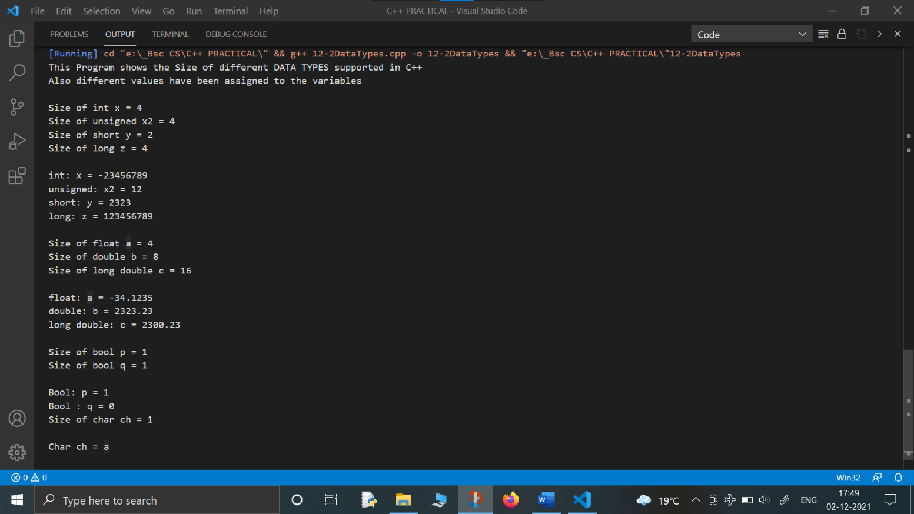

**#2 Program to print ASCII code of a character: input by the user, from A to Z:**

#include<iostream>

using namespace std;

int main(){

char ch1,ch;

cout<<"Enter any character here: ";

cin>>ch;

cout<<"\nThe entered character is "<<ch1<<endl;

cout<<"The ASCII Code of "<<ch1<<" is "<<(int)ch<<endl;

cout<<"The Alphabets & their ASCII Values from A to Z are "<<endl;

ch='A';

while(ch<='Z') {

cout<<ch<<" : ASCII CODE = "<<(int)ch<<endl;

ch=ch+1;

}

return 0;

}

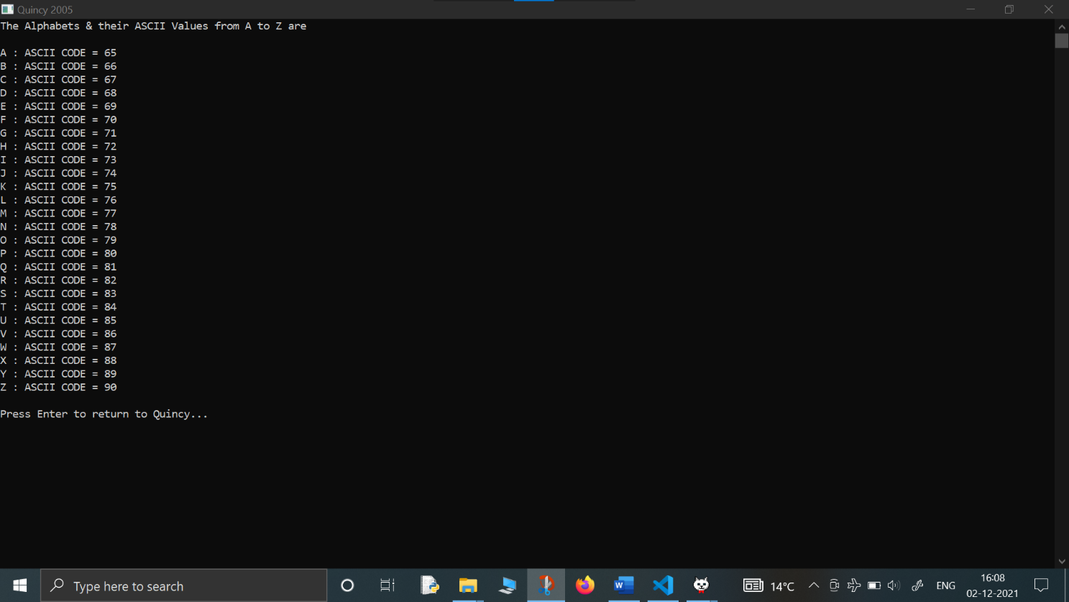

**#3 Write a C++ program that prints the sum of numbers in a series given by the user (1 to n):**

#include <iostream>

using namespace std;

int main(){

int n, sum, i;

cout<<"This program displays the sum of numbers from 0 to n for the given value of n"<<endl;

cout<<"Enter the value of n here : ";

cin>>n;

sum=0;

i=0;

while (i<=n){

sum=sum+i;

i=i+1;

}

cout<<"\nThe sum of numbers from 0 to "<<n<<" is "<<sum;

return 0;

}

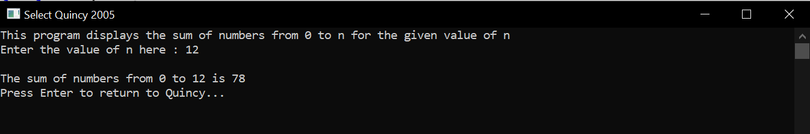

**#4- WAP to display the output of the series: 1-1/(2*2)+1/(3*3)-1/(4*4)+…….1/(n*n):**

#include<iostream>

#include<math.h>

using namespace std;

int main() {

int n;

cout<<"THIS PROGRAM CALCULATES AND DISPLAYS THE OUTPUT OF THE GIVEN SERIES"<<endl;

cout<<"1-1/(2*2)+1/(3*3)-1/(4+4)+......1/(n*n)"<<endl;

cout<<"\twhere n refers to number of terms"<<endl;

cout<<"\nEnter the value of n here : ";

cin>>n;

float sum=0.0;

float i=1;

while (i<=n){

sum=sum+pow(-1,i+1)*(1.0/(i*i));

i=i+1;

}

cout<<"The sum of the series is "<<sum<<endl;

return 0;

}

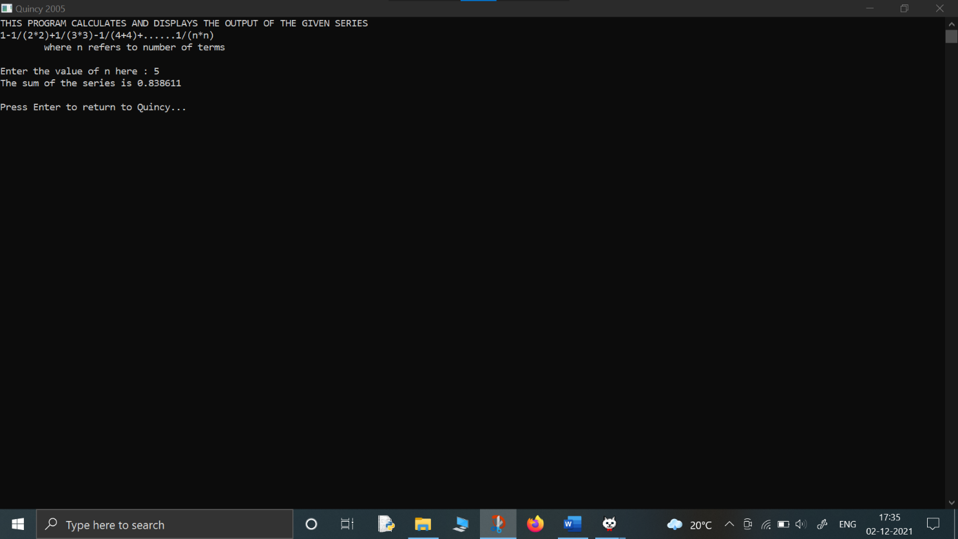

**#5- WAP to display Factorial of a number entered by the user:**

#include <iostream>

using namespace std;

int main(){

int num;

cout<<"THIS PROGRAM FINDS THE FACTORIAL OF A GIVEN NUMBER"<<endl;

cout<<"Enter the number here : ";

cin>>num;

int fact=1;

int i=1;

while (i<=num){

fact=fact*i;

i=i+1;

}

cout<<"The factorial of "<<num<<" is "<<fact<<endl;

return 0;

}

